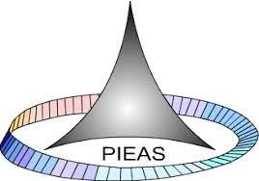

PAKISTAN INSTITUTE OF ENGINEERING AND APPLIED SCIENCES

***Computing Fundamentals & Programming***

**FALL 2020**

**Laboratory Exercise-12 (Air Reservation Code)**

**Department: Physics**

**Name: Umar Shifaqat**

**Serial No. 43**

**Roll No. BS-20-GB-100864**

**Date: December 20, 2020**

**Air Reservation Code**

**INPUT**

#include<stdio.h>

#include<conio.h>

#include<stdlib.h>

int seat[13]={0};

void business(void);

void economy(void);

void main()

{

char y;

int i,j;

puts("\tWelcome to Pakistan Eagle Flight PE-49 from Islamabad to Madinah");

puts("\tDo you want to reserve a seat ?");

puts("\tPress \'Y\' to start reservation");

puts("\tPress \'N\' to close the program ");

while(1)

{

printf("\t");

y=getch();

if(y=='N'||y=='n')

{

getch();

getch();

exit(2);

}

else if(y=='Y'||y=='y')

break;

}

while(2)

{

j=0;

for(i=1;i<=12;i++)

if(seat[i]==0)

j=1;

if(j==0)

break;

puts("\n\tPress 1 for Business Class");

puts("\tPress 2 for Economy Class");

printf("\t");

y=getche();

if(y=='1')

business();

else if(y=='2')

economy();

}

puts("\n\tAll seats in flight PE-49 have been reserved");

getche();

getche();

}

void business(void)

{

int i,j=0,num,fair_business=90000;

for(i=1;i<=4;i++)

if(seat[i]==0)

j=1;

if(j==0)

{

puts("\n\t\aThere are no seats left in this class");

return;

}

puts("\n\tThe available seats in business class are:");

for(i=1;i<=4;i++)

if(seat[i]==0)

printf("\tSeats No. %d",i);

puts("\n\tPlease select the seat number of your choice");

printf("\tSeat No. ");

scanf("%d",&num);

if(num<1||num>4)

{ puts("\t\aYou Entered wrong Seat Number");

return; }

else if(seat[num]==1)

{ puts("\n\t\aSorry! The seat has already been reserved");

return; }

if(num%4==0)

fair_business+=2*fair_business/100;

printf("\n\tYour seat No. %d has been reserved. Total fare is Rs.%d//=",num,fair_business);

puts("\n\tThanks to Fly with Pakistan Eagle. Have a Nice Journey");

seat[num]=1;

}

void economy(void)

{

int i,j=0,num,fair_economy=54000;

for(i=5;i<=12;i++)

if(seat[i]==0)

j=1;

if(j==0)

{

puts("\n\t\aThere are no seats left in this class");

return;

}

puts("\n\tThe available seats in business class are:");

for(i=5;i<=12;i++)

{

if(seat[i]==0)

printf("\tSeats No. %d",i);

}

puts("\n\tPlease select the seat number of your choice");

printf("\tSeat No. ");

scanf("%d",&num);

if(num<5||num>12)

{ puts("\t\aYou Entered wrong Seat Number");

return; }

else if(seat[num]==1)

{ puts("\t\n\aSorry! The seat has already been reserved");

return; }

if(num%4==0)

fair_economy+=2*fair_economy/100;

printf("\n\tYour seat No. %d has been reserved. Total fare is Rs.%d//=",num,fair_economy);

puts("\n\tThanks to Fly with Pakistan Eagle. Have a Nice Journey");

seat[num]=1;

}

**OUTPUT**

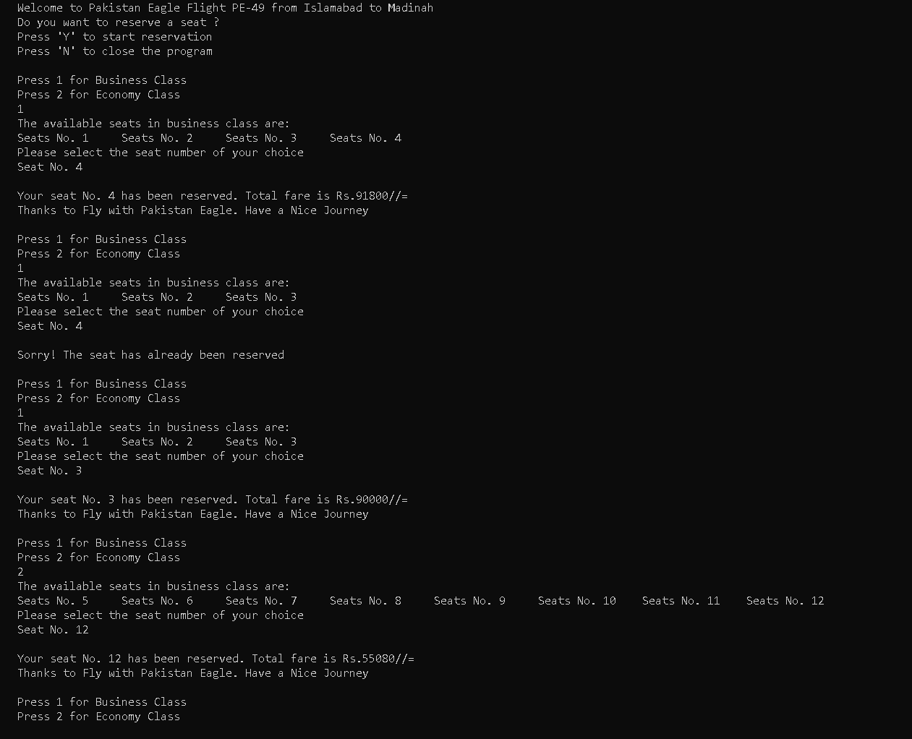

**THE END**